CHANGES HISTORY
PIC | Date | Remarks
BJM.MR | 2018.05.04 | Created
Ghaida | 2018.05.07

TOC
- Parameter Ata Transaction Trx Type1
- Parameter Ata Transaction Trx Type2
- Parameter Ata Charges
- Parameter Ata Transaction Trx Link
- Parameter Ata Transaction Trx Flag

Diagram ENTITY RELATIONSHIP

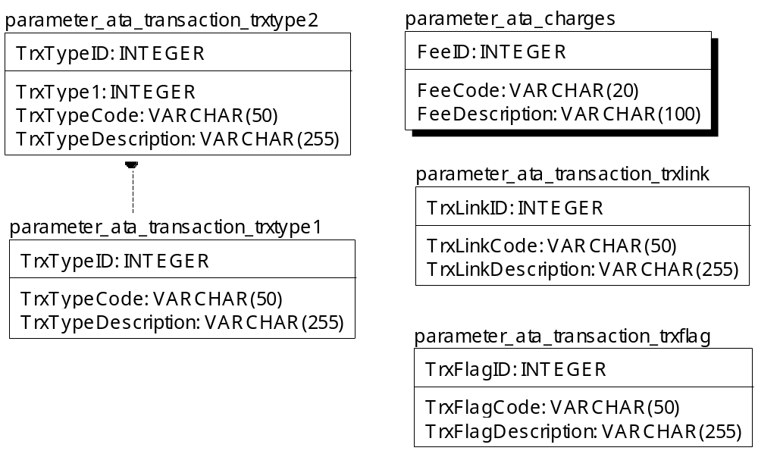

TABLE RELATIONSHIP
No | Table 1 | Table 2 | Type (1:1; 1:N; M:N) | Description
 | parameter_ata_trnsaction_trxtype1 | parameter_ata_trnsaction_trxtype2 | M:N

Name |  | parameter_ata_transaction_trxtype1
Objective
No | Column |  | Type | Rule  (PK, FK, Key, NN, Unik, Index) | Description
1. | TrxTypeID |  | Integer | NN
2. | TrxTypeCode |  | Varchar(50) | NN
3. | TrxTypeDescription |  | Varchar(255) | NN

SAMPLE DATA
No | Column | Sample 1 | Sample 2 | Sample 3 | Sample 4
1. | TrxTypeID | 1 | 2 | 3 | 4
2. | TrxTypeCode | SUBSCRIPTION | REDEMPTION | DIVIDEND | BEGINNING BALANCE
3. | TrxTypeDescription

Name |  | parameter_ata_transaction_trxtype2
Objective
No | Column |  | Type | Rule  (PK, FK, Key, NN, Unik, Index) | Description
1. | TrxTypeID |  | Integer | NN
2. | TrxType1 |  | Integer | NN
3. | StatusCode |  | Varchar(50) | NN
4. | StatusDescription |  | Varchar(255) | NN

SAMPLE DATA
No | Column | Sample 1 | Sample 2 | Sample 3 | Sample 4
1. | TrxTypeID
2. | TrxType1
3. | StatusCode
4. | StatusDescription

Name |  | parameter_ata_charges
Objective
No | Column |  | Type | Rule  (PK, FK, Key, NN, Unik, Index) | Description
1. | FeeID |  | Integer | NN
2. | FeeCode |  | Varchar(20) | NN
3. | FeeDescription |  | Varchar(100) | NN

SAMPLE DATA
No | Column | Sample 1 | Sample 2 | Sample 3 | Sample 4
1. | FeeID
2. | FeeCode
3. | FeeDescription

Name |  | parameter_ata_transaction_trxlink
Objective
No | Column |  | Type | Rule  (PK, FK, Key, NN, Unik, Index) | Description
1. | TrxLinkID |  | Integer | NN
2. | TrxLinkCode |  | Varchar(50) | NN
3. | TrxLinkDescription |  | Varchar(255) | NN

SAMPLE DATA
No | Column | Sample 1 | Sample 2 | Sample 3 | Sample 4
1. | TrxLinkID
2. | TrxLinkCode
3. | TrxLinkDescription

Name |  | parameter_ata_transaction_trxflag
Objective
No | Column |  | Type | Rule  (PK, FK, Key, NN, Unik, Index) | Description
1. | TrxFlagID |  | Integer | NN
2. | TrxFlagCode |  | Varchar(50) | NN
3. | TrxFlagDescription |  | Varchar(255) | NN

SAMPLE DATA
No | Column | Sample 1 | Sample 2 | Sample 3 | Sample 4
1. | TrxFlagID | 1 | 2 | 3 | 4
2. | TrxFlagCode | NONE | NTA | LA | IS
3. | TrxFlagDescription | None | New Transaction Account | Liquidation Account | Initial Subscription

